

Applied Surface Science Advances 15 (2023) 100394
Contents lists available at ScienceDirect

Applied Surface Science Advances
journal homepage: www.sciencedirect.com/journal/applied-surface-science-advances

Development of environmental friendly high performance Cs₂TiBr₆ based  perovskite solar cell using numerical simulation
P. Arockia Michael Mercy *, K.S. Joseph Wilson
PG & Research Department of Physics, Arul Anandar College, Madurai Kamaraj University, Madurai, 625514, Tamilnadu, India

A R T I C L E I N F O

Keywords:
Lead free perovskite solar-cell Cs₂TiBr₆
CuSbS₂ CdS TCO
SCAPS-ID
A B S T R A C T

The stability and toxicity problems pose a significant obstacle to the practical application of lead-based perov- skite solar cells. Ti-based all-inorganic perovskite solar cells (PSCs) may be essential for the marketing of elevated PSCs under such conditions. This study investigates the theoretical viability of a Cs₂TiBr₆-based PSC that is efficient, lead-free, and environmentally benign. The evaluation of several electron transport layers (ETLs) and hole transport layers (HTLs) is done in an attempt to choose materials that would provide more stable and efficient PSCs. The emergence of novel Au/CuSbS₂/Cs₂TiBr₆/CdS/TCO configurations is a direct result of investigating factors such as charge transport materials and their thickness, electron transport materials, absorber thickness, absorber defect density, TCO and its thickness, back metal contacts, series resistance, and shunt resistance. SCAPS-1D software is employed to optimize and analyze each composite layer in order to enable enhanced performance. An optimization results in a maximum power-conversion efficiency of 23.77% for the suggested PSC. The achieved outcomes confirmed that Cs₂TiBr₆ can contribute significantly to the devel- opment of the highly effective lead-free all-inorganic perovskite solar cell technology.

Introduction

In the upcoming decades, photovoltaic technology has indeed been lauded as a viable approach to substitute exhausted fossil fuels [1]. Despite the significant developments in solar cell technology, finding materials that are effective, eco-friendly, affordable, and widely acces- sible continues to be challenging [2]. The most intriguing issue has arisen as a result of the latest innovations in materials, specifically their low cost, high stability, and ease of production for modern technology solar cells [3]. Numerous solar cell varieties exist that meet the re- quirements of high efficiency and low price. Perovskite solar cells (PSCs) have attracted attention from all over the world in recent years, from the lab to industrial fabrication, with a power conversion efficiency (PCE) higher than 25% [4]. The thin film solar cell is among the most suitable alternatives in this regard (TFSC). The thickness of TFSCs is extremely thin, ranging from a few nanometers to tens of micrometres [5]. As a result, they are regarded as low-cost cells. However, some TFSCs call for incredibly rare substances like indium (In), selenium (Se), or tellurium (Te) [6].
Silicon solar cells are the most extensively used photovoltaic device, although they are expensive when compared to other energy sources. Si
cannot be used in solar applications without cleanroom technology, which significantly raises the cost of those applications [7,8]. A brand-new class of solar cells built with both organic and inorganic components was suggested as a solution to these issues. Due to their inexpensive cost of manufacture and remarkable improvement in effi- ciency, which increased from 9.7% [9] to more than 20% [6,10], PSCs recently attracted substantial attention in energy harvesters. Recent years have seen a significant increase in the use of lead halide perovskite solar cells (LHPSCs) because of their affordability, ideal bandgap, high absorption coefficient, and long carrier diffusion length [11,12,13,14]. With regard to these materials, lead-based metal halide perovskites are desirable due to their high PCE. The toxicity of lead remains a major obstacle to the widespread use of PSCs, even though they came close to an efficiency of about 22% [15,13]. A, B, and X make up the triangle-shaped structure of halide perovskites (HPs), where A stands for a monovalent cation, B for a divalent metal cation, and X for a halide anion [16].
In general, such semiconductor materials exhibit unique optoelec- tronic features such as greater absorption coefficients, longer carrier diffusion lengths, weakly bound exciton, and a wide bandgap tuning range [17]. Although the PCE of PSCs has increased, there is still an issue

* Corresponding author.
E-mail address: madonnacollegemdu@gmail.com (P.A.M. Mercy).
https://doi.org/10.1016/j.apsadv.2023.100394
Received 9 September 2022; Received in revised form 7 February 2023; Accepted 26 February 2023
Available online 28 March 2023
2666-5239/© 2023 The Author(s). Published by Elsevier B.V. This is an open access article under the CC BY-NC-ND license (http://creativecommons.org/licenses/by- nc-nd/4.0/).

due to the toxicity of lead and the fact that the PSCs with the highest PCE are made up primarily of organic cations, such as methylammonium and formamidinium ions [18]. The materials’ extremely volatile and hy- groscopic ions render the device intolerant to heat and moisture [19]. Perovskites contain lead, which is dangerous for the environment and human health and is a serious problem for their industrial applications [20]. Lead halide perovskite solar cells (PSCs), which are inexpensive and have excellent power conversion efficiencies, are a promising new technology for future clean energy harvesting [21]. The exceptional photophysical properties of all-inorganic lead halide perovskite (CsPbX₃) nanocrystals (NCs) have led to the development of this mate- rial as a very promising new generation of light emitters. A simple way to manufacture LEDs and treat sensitive lead halide perovskite NCs would lay the groundwork for producing high-quality optoelectronic components for upcoming lighting technologies. This method could be used on a large scale and at a low cost [22]. The instability and decomposition of lead halide perovskites under various circumstances is a basic issue with them. CsCu₂I₃ single crystals that are lead-free and have improved photoluminescence quantum yield (PLQY) stability and uniform surface morphology.
The development of lead-free single crystals encourages the use of CsCu₂I₃ in wireless VLC and yellow lighting, among other applications [23]. Unfortunately, the cause of photoluminescence (PL) emission is still open for dispute, and it’s unknown why PL exhibits an aberrant sensitivity to pressure. Consequently, the proposal of lead-free perov- skites for high-efficiency solar cells is receiving a lot of attention from scientists [24]. Many of these materials show encouraging photovoltaic responses [25]. Cs₂TiBr₆ has been discovered as a potential material in Pb-free perovskites by the latest research [26]. Additionally, diffusion lengths above 100 nm have been recorded, reinforcing the notion that the non-radiative recombination rate is minimal. It has also been noted that exposure to thermal stress, light, and humidity has a high level of stability. In terms of Pb-free PSCs, it is a very good alternative because it incorporates a variety of desirable characteristics. Remarkable opto-
electronic potential exists for Ti-based A₂₊₁ T_{i+4} X_{6–1} double perov-
skites, which are toxic-free and lead-free [27]. In next-generation solar applications, methylammonium lead halide perovskite may be substituted by Cs₂TiBr₆, a direct-energy bandgap perovskite compound with enhanced optical, electrical, and photovoltaic properties [28,29]. Cs₂TiBr₆ is a well-tolerated and long-lasting perovskite semiconductor due to its resistant titanium (Ti) [30].

Design of novel perovskite solar cell

Fig. 1 depicts the configuration of the multilayered Cs₂TiBr₆ solar cell used in the present investigation. A photon’s path to become an electron-hole pair is captured by an absorber layer, which is the fundamental part of photovoltaic. A sandwich of two electrodes and an absorber layer might be adequate for a photovoltaic response. But the maximum solar cell performance is obtained when electrons and holes are spread evenly across the photovoltaic system [31].
The sandwiching of the hole transport layer (HTL) and the electron transport layer (ETL) for a balanced charge distribution can result in a PSC [32]. In terms of layer selection, both HTL and ETL must carry out three properly specified tasks: (i) extract holes/electrons from the absorb layer; (ii) prevent recombination by blocking opposite charges from entering the absorb layer; and (iii) gather holes/electrons from the absorb layer and direct them to their proper electrodes [33,34]. The extraction of electrons and holes from perovskite absorber layers relies on compounds known as HTL and ETL, which are crucial. Cu₂O, CuAlO₂, CuSbS₂, CuSCN, MoO₃, SpiroOMeTAD, P₃HT, and PEDOT:PSS are a few examples of these HTL substances. For PSCs, CuSbS₂ has been found to be the most efficient HTL among them [35]. As a result, for this study, we chose CuSbS₂ as the HTL. The electron transport layer (ETL) of a solar cell is described in the literature as being composed of TiO₂ [36], ZnO [36], STO [37], IGZO [36], PCPM [38], ZnSe [39], CdS [40], and
WO₃ [38]. CdS is recognized as an ETL for perovskite performance because of its excellent efficiency in comparison to all other ETLs. Among these materials for transporting electrons, CdS has a number of exceptional advantages over others, including solution processing, remarkable electrical properties, and high mobility [41]. CdS is gener- ated in this investigation as an ETL. An optimum device is a perovskite solar cell composed of Au/CuSbS₂/Cs₂TiBr₆/CdS/TCO.

Design and simulation

This study made use of the SCAPS-1D (v3.3.07), a one-dimensional (1-D) photovoltaic simulator developed by ELIS, University of Gent, Belgium [42,43]. SCAPS 1D employs four different sets of equations to calculate the densities of electrons and holes separately [44]. These equations are provided below:
1) The Poisson equation’s differential form, expressed in terms of electrostatic potential, is shown below.

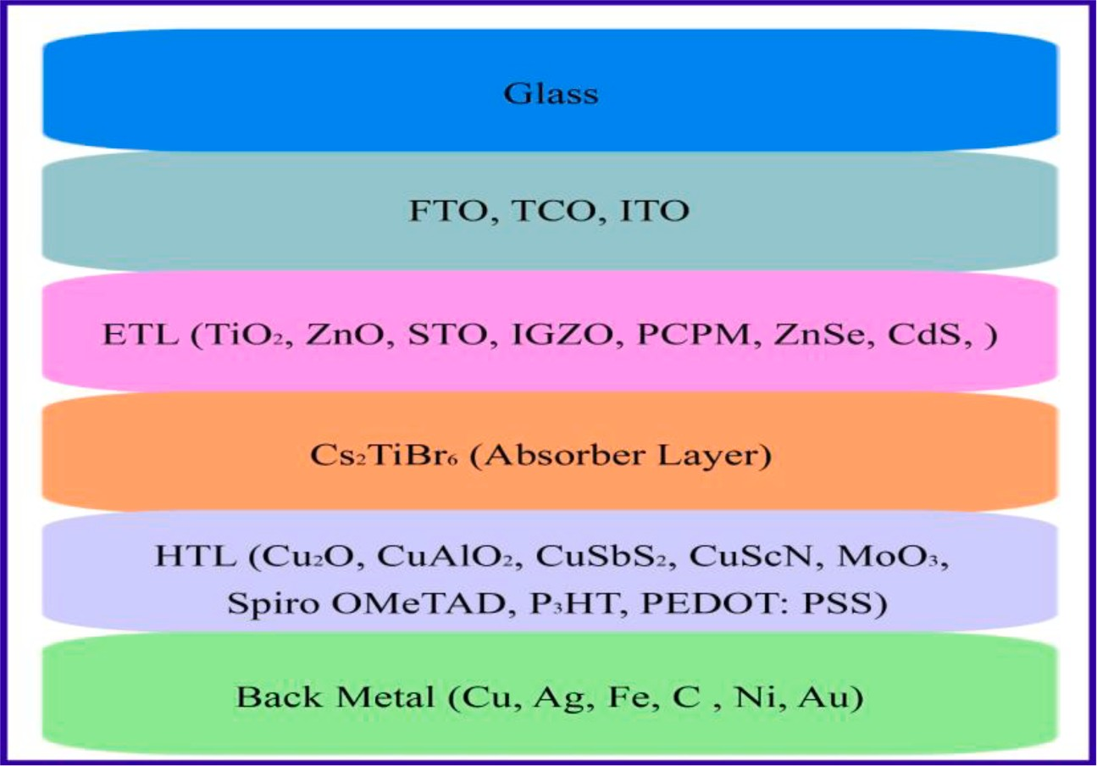
Fig. 1. Configuration of CS₂TiBr₆ based Solar Cell.

d2 ϕ(x) e

dx2 = ε0 εr p(x) — n(x) + N_{D}(x) — N_{A} + ρ_{p} — ρ_{n}) (1)
where ϕ is the is the electrostatic potential, e is electronic charge, the permittivity of vacuum is ε₀, ε_{r} is relative permittivity, N_{A} stands for
where A, B are constant, h is plank constant, υ is frequency of photons and E_{g} is the band gap of the absorber layer. For the sake of convenience, the band discontinuity between the interfaces of the several layers is
insignificant. For this analysis, the environmental temperature is 300 K,

shallow acceptor impurity density while N_{D} impurity density. Similarly, ρ
stands for shallow donor
and the sun spectrum AM.1.5 (1000 W/m2) is being used. Tables 1 and 2
contain a list of all the physical and electrical parameters of each layer

_{p} represents hole density distribution and
ρ_{n} indicates electron density distribution, with n(x) and p(x) indicating electron and hole density as functions of x.
1) The continuity equation is shown below.
dJ_{n}
dx = G — R (2)
dx = G — R (3)
dJ_{p}

where J_{n} and J_{p} denote the electron and hole current densities, G rep- resents the generation rate, and R represents the recombination rate.
1) The electron and hole current densities are given by the charge transport equations as follows
that have been acquired from the scientific literature.
The following is a report on the simulations’ photovoltaic device parameters, with the doping concentration only provided as a reason- able approximation that will subsequently be optimized.

Results and discussion

For our innovative device, we investigate the HTL, absorber and TCO thickness in this section as well as the electron transport materials (ETMs) and hole transport materials (HTMs). Additionally, we improve the active layer defect density as well as the impact on series and shunt resistance, while also suggesting a unique structure and its relationship to operating temperature.

  - Optimization of ETL, HTL for Cs₂TiBr₆ perovskite absorber

The performance of all device configurations with each HTL and ETL

dn dϕ
μ
J = D + n
(4)
variation while maintaining Au as the back metal contact is shown in

n ndx
^{n} dx
Fig. 2. In order to obtain an optimized structure of the PSC, the inorganic and organic materials are examined as hole transport materials (HTMs).

J_{p} = D_{p}dp + μ_{p}p dϕ
(5)
These materials include Cu₂O, CuAlO₂, CuSbS₂, CuSCN, MoO₃, Spiro-

dx dx
OMeTAD, P₃HT, and PEDOT:PSS. Table 2 contains a list of the param- eters related to each HTM. The J-V characteristics on various HTLs with TiO₂ as ETL are evaluated and presented in Table 3 (a). In a similar

where µ_{n} is the electron mobility and µ_{p} is the hole mobility.
1) The following equation can be used to determine the absorption coefficient with respect to wavelength α(λ),
α(λ) = (A + B √h̅̅̅υ̅̅̅—̅̅̅̅̅E̅̅̅̅̅) (6)
manner, the effects of HTLs on different ETLs are also researched and are provided in Table 3(b) to (h). These analyses revealed that CuSbS₂ is a preferable HTL on the PSC of the Cs₂TiBr₆ absorber versus other HTL configurations. The J-V characteristics of the HTMs, which are displayed in Table 3(a) to 3(h), provide information about the product perfor- mance for each of the ETLs used in the device. Glass/TCO/CdS/

hυ ^{g}

Table 1
Cs₂TiBr₆/CuSbS₂/Au is discovered to have very high performance. The obtained values for the PCE, FF, J_{SC}, and V_{OC} are 19.15%, 88%, 19.39

Input parameters of ETL.
Parameter | FTO [45] | TiO₂ [36] | ZnO [36] | STO [37] | IGZO [36] | PCBM [38] | ZnSe [39] | CdS [40] | WO₃ [38] | Cs₂TiBr₆ [45]
Thickness | 500 | 30 | 30 | 30 | 30 | 30 | 30 | 30 | 30 | 900
(nm)
E_{g} | 3.2 | 3.2 | 3.3 | 3.2 | 3.05 | 2 | 2.81 | 2.4 | 2.92 | 1.6
(eV)  χ(Ev) | 4.4 | 3.9 | 4.1 | 4 | 4.16 | 3.9 | 4.09 | 4.18 | 4.590 | 4.47
εr | 9 | 9 | 9 | 8.7 | 10 | 4 | 8.6 | 10 | 5.76 | 10
NC  (cm—3) NV | 2.2  1.8×1019 | 1×1021  2×1020 | 4×1018  1×1019 | 1.7×1019  2×1020 | 5×1018  5×1018 | 1E+21  2E+20 | 2.2×1018  1.8×1018 | 2.2×1018  1.9×1019 | 1.96E+19  1.96E+19 | 1E+19  1E+19
μ_{n} | 90 | 20 | 100 | 5.3×103 | 15 | 1E—2 | 4×102 | 100 | 1E+1 | 4.4E+0
μ_{p} (cm2/V_{S}) | 90 | 10 | 25 | 6.6×102 | 0.1 | 1E—2 | 1.1×102 | 25 | 1E+1 | 2.5E+0

(cm—3) (cm2/V_{S})
Ve | 1×107 | 1×107 | 1×107 1×10 | 7 1×107 | 1×107 | 1×107 | 1×107 | 1×107
Vh | 1×107 | 1×107 | 1×107 1×10 | 7 1×107 | 1×107 | 1×107 | 1×107 | 1×107

(cm/s)

(cm/s)
x1018

1 × 107
1 × 107

ND
(cm-3) NA
(cm-3)
N_{t}
₍1/cm3)
7×102 1×1019 1×1018 2×1016 1×1018 1E+20 1×1018 1×1018 3.68E+19 1E+19
0 0 0 0 0 0 0 0 0 1E+19
1×1014 1×1014 1×1014 1×1014 1×1014 1×1014 1×1014 1×1014 1×1014 1 × 1014

Input parameters of HTL.
Parameter Cu₂O [46] CuAlO₂ [47] CuSbS₂ [48] CuSCN [36] MoO₃ [40] Spiro-OMeTAD [36] P3HT [36] PEDOT:PSS [49]
Thickness (nm) 30 30 30 30 30 30 30 30
E_{g}(eV) 2.17 3.46 1.58 3.2 3 3 1.85 2.2
χ(Ev) 3.2 2.5 4.2 1.9 2.5 2.45 3.1 2.9
εr 7.1 60 14.6 10 12.5 3 3.4 3

NC(cm—3) 2.02×1017
NV(cm—3) 1.1×1019
2.2x1018
1.8x 1019
2x1018
1x10—4
2.2x 1019
1.8x1019
2.2x 1018
1.8x 1019
1x1019 1E+22 2.2E+15
1x1019 1E+22 2.2E+17

μ_{e}(cm2/V_{S}) 200 2 49
1x10—4 100 2×10—4 1E—4
2x10—3

μ_{p} (cm2/V_{S}) 80 8.6 49
1x10—1 25 2×10—4 1E—3 2×10—3

Ve(cm/s) Vh(cm/s)
1x107
1x107
1x107
1x107
1x107
1x107
1x107
1x107
1x107
1x107
1x107
1x107
1x107
1x107
1x107
1x107

ND(cm-3) 0 0 0 0 0 0 0 0

NA(cm-3) 9×1021
3x1018
1.38x 1018
1x1015
1x1018 2×1018 3.17 E+13 1E+17

N_{t} ₍1/cm3)
1x1014
1x1014`
1x1014
1x1014
1x1014
1x1014
1x1014
1x1014

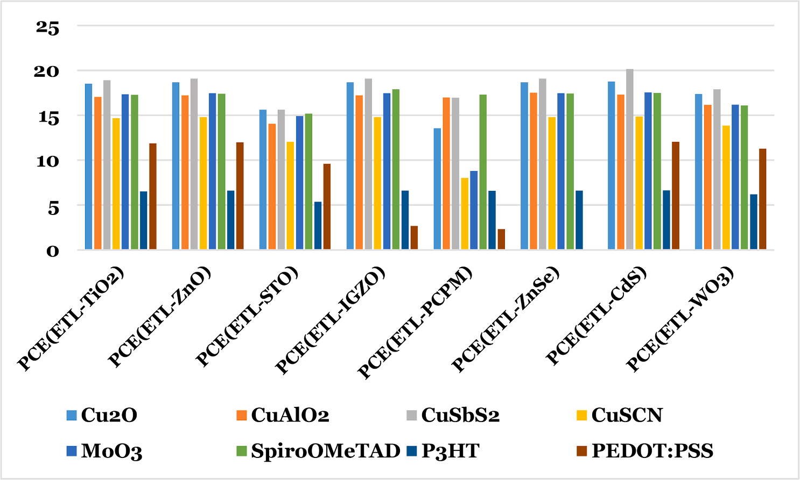
Fig. 2. Impact of different HTLs and ETLs on PCE of Cs₂TiBr₆ PSC.

mA/cm2, and 1.1145 V respectively. The results collected demonstrate that inorganic HTL enhances the device’s PCE. Excellent transparency, improved band alignment, and greater stability are some benefits of inorganic HTL. The ETL and HTL layers for PSC enhancement underwent numerous simulations. The CdS as ETL and CuSbS₂ as HTL-based Cs₂TiBr₆ PSCs are shown to have the highest PCE variation.

  - Optimizing the thickness of the absorber layer

Fig. 3(a) and (b) illustrate how the thickness of the absorber affects the performance parameters. By varying the thickness of the absorber layer, PSC features can be tailored. Fig. 3(a) shows a graph of the Voc and PCE while Fig. 3(b) shows a graph of the Jsc and FF characteristics of PSC as a consequence of absorber thickness. For our evaluation, the absorber thickness was changed from 100 nm to 1300 nm. As the absorber layer thickness is increased, it was clear that all solar cell output parameters significantly increased. At a thickness of 100 nm, the value of Voc is determined to be 1.1013 V, and it rises to 1.1147 V at a thickness of 700 nm, then it starts to decrease. A thin layer’s inadequate ability to absorb light results in a lower PCE. The PCE of PSCs grows with the thickness of the absorber and reaches its highest value at 1000 nm. Because of charge recombination, photo generated carriers were less
abundant in absorbers thicker than 1000 nm. According to this inves- tigation, the perovskite absorption film’s thickness has a significant impact on how well the solar cell functions. It has been found that low
PCE occurs when the film thickness is too thin because photons are ineffectively absorbed in the film. A solar cell’s PCE will be reduced if the film thickness is excessively thick because of carriers that recombine [50]. As a result, in the current work, the absorber layer’s thickness is tuned to be 1000 nm, which is significantly important to limit charge recombination and hence increase PV performance. Additionally, Jsc was seen to increase linearly up to an increase in absorber thickness. The reason for this is because when thickness increases at higher wave- lengths, photon absorption increases. Similarly, FF also increased as
thickness increased. These graphs show the highest PCE of 21.8%, Voc of 1.1138 V, Jsc of 23.9897 mA/cm2, and FF of 81.6% at 1000 nm absorber optimum thickness.

  - HTL layer thickness optimization

The structure with CuSbS₂ has the best PCE, as shown in Fig. 2, hence we selected CuSbS₂ to optimize thickness. We have changed the HTL thickness from 20 nm to 180 nm to achieve the best results [51], taking into consideration the periodic viability of the manufacture process of PSCs. The HTL thickness optimization curve is illustrated in Fig. 4. As the HTL thickness increases, Jsc gradually rises as well. With an increase in HTL thickness, the FF initially rises and subsequently falls. It is a sign of a change in series resistance when the fill factor varies with HTL thickness. PCE reached 22.11% at the 120 nm optimum thickness. Since a thin HTL (less than 50 nm) does not completely cover the perovskite

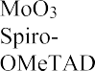
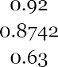
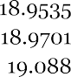
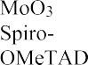
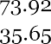
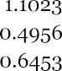
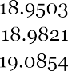

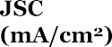
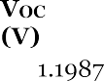
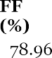
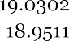
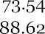
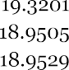
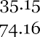

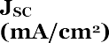
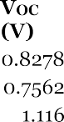
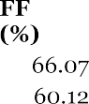
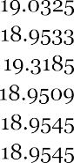
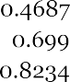
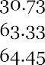

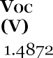
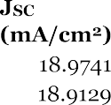
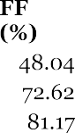
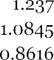
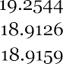
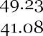
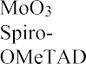
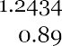
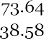
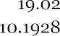
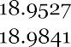
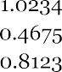

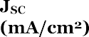
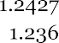
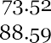
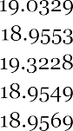
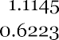
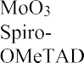
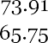
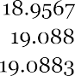

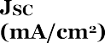
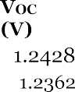
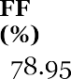
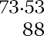
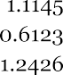
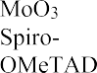
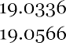
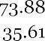
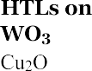
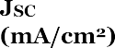
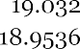
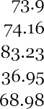
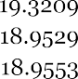
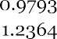
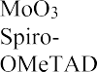

Table 3

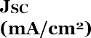
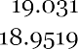
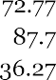
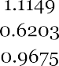
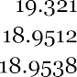

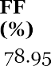
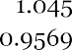
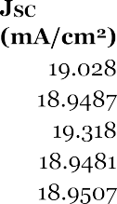
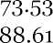
Impact of different ETLs (a) TiO2, (b) ZnO, (c) STO, (d) IGZO, (e) PCPM, (f) ZnSe, (g) CdS, (h) WO3 on J-V charateristics with various HTLs.

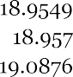

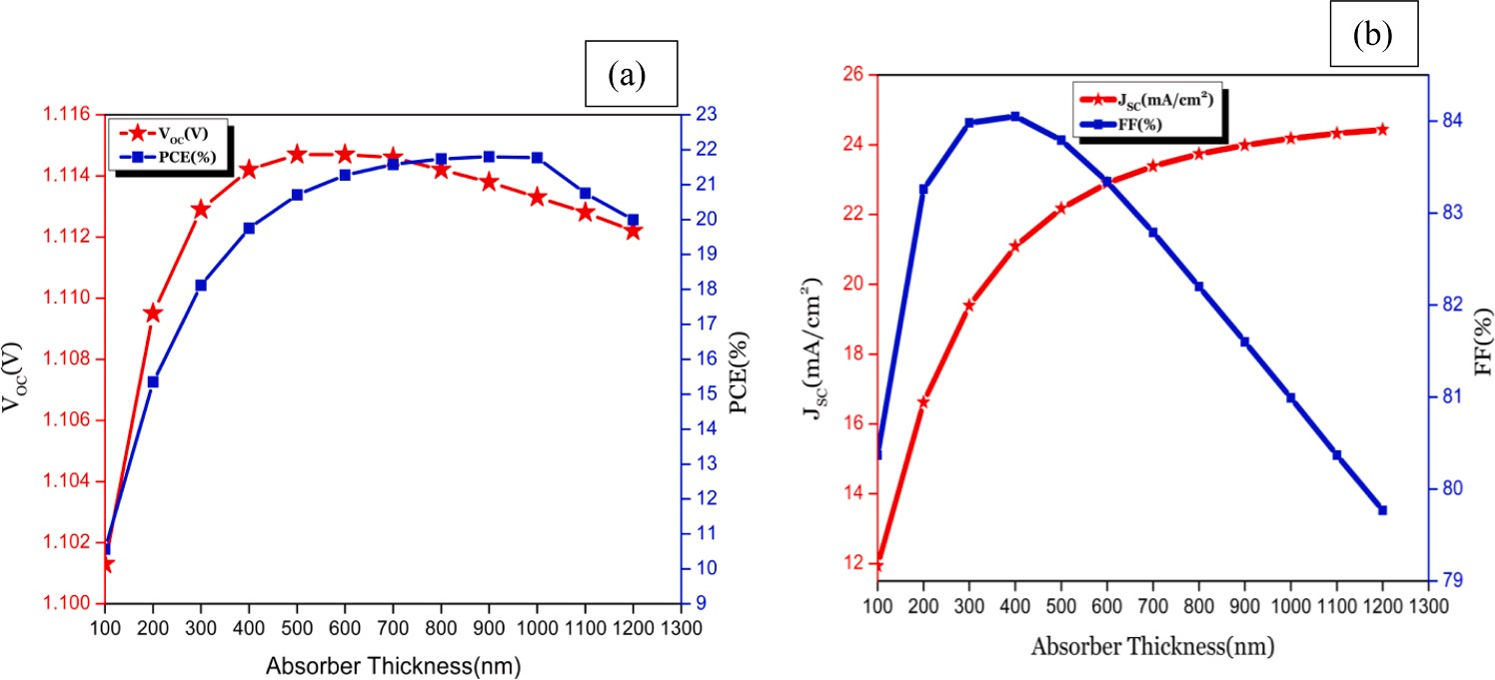
Fig. 3. (a) Variation of V_{oc} and PCE with thickness of the absorber layer. (b) Variation of J_{sc} and FF with thickness of the absorber layer.

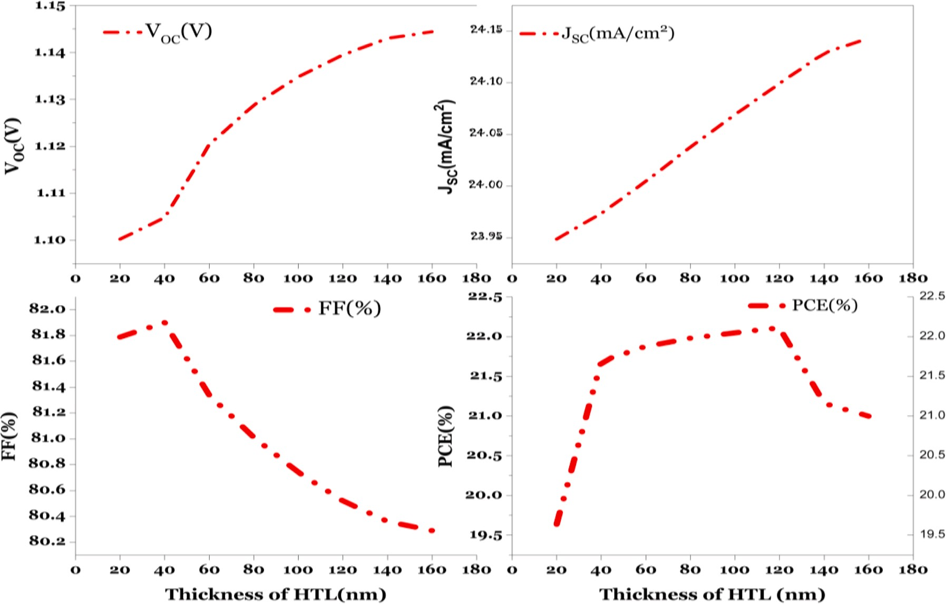
Fig. 4. Variation of PSC parameters with thickness of the HTL layer.

layer, the possibility of recombination is significant. This is because the longer path length for charge carriers to reach the back electrode in- creases series resistance. High efficiency can be achieved with an optimal HTL thickness between 100 and 200 nm [50,51]. This implies efficient charge transport, low series resistance, good fill factor, and

Table 4
Performance of different front electrodes in a solar cell.
Solar Cell Parameters ITO FTO TCO
PCE (%) 21.22 22.10 22.26

little device recombination. If the thickness falls short of the optimum
Open Circuit Voltage(V)
2
1.1332 1.1395 1.1397

thickness, HTL may not completely enclose the emerging perovskite crystals that are present in the perovskite layer. Therefore, a very thin
(50 nm) or thick (> 200 nm) HTL is not suited for high efficiency. The
structure Cs₂TiBr₆ used as HTM offers the best performance at 120 nm with the Voc of 1.1395 V, Jsc of 24.0995 mA/cm2, FF of 80.52%, and PCE of 22.11%.As a result, we decide that CuSbS₂ is the best HTM for
Cs₂TiBr₆ based PSC with a 120 nm optimal thickness.

  - Effect of various front electrodes on the PSCs performance

Table 4 evaluates the performance metrics for PSCs employing ITO
Short Circuit Current(mA/cm ) 24.333 24.0995 24.2523
Fill Factor (%) 76.97 80.52 80.54

(Indium Tin Oxide), FTO (Fluorine Doped Tin Oxide), and TCO (trans- parent conducting oxide) as the front transparent electrodes. The TCO electrode is clearly a superior option than the ITO and FTO electrodes for this PSC to be used in a solar cell when the table is taken into account.

  - Optimization of TCO layer thickness

When TCO is being used as the front electrode, the PSC operates

significantly more effectively. Fig. 5 illustrates the PSC characteristics related to TCO thickness over the thickness range of 50 nm to 550 nm. The FF, Jsc, V_{OC}, and PCE initially start rising and then begin to fall as the TCO thickness increases. Since TCO serves as both the front electrode and the backside reflector in a solar cell, it is crucial [52]. The optical absorption of incident light increases as TCO thickness increases in the layer at the front side of the cell, which in turn causes internal scattering and lengthens the path of light [53,54]. As a result, the appropriate TCO
thickness is 50 nm, which yields values for V_{OC}, J_{SC}, FF, and PCE of 1.1399 V, 24.38 mA/cm—2, 80.56% and 22.39%, respectively.

  - Optimization of absorber defect density

The defect density of absorber interfaces is examined on a scale ranging from 1013 cm—3 to 1017 cm—3. Fig. 6 shows the PCE, while the
Table 5 shows how the J-V characteristics of the design are affected by varying interface defect densities. In terms of defect density, perovskite
solar cells based on Cs₂TiBr₆ have the maximum PCE of 23.77% at the defect density of 1013 cm—3 when compared to other defect densities as
illustrated in Figure. Table 5 displays the outcomes of Voc, J_{SC}, and FF corresponding to defect density of 1013 cm—3 are better.

  - The impact of the rear metal work function on the PSC’s execution

Studies have shown that larger work functions make solar cells more efficient. The ohmic contact increases when the work function value increases while the carrier’s barrier height decreases. Table 6 and Fig. 7 illustrate the many metals that have been employed as back contact electrodes in PSCs.
Copper (Cu), iron (Fe), carbon (C), and gold (Au) have all been simulated as back contacts for PSCs. For electrons to be collected and delivered to the load, the ETL and electrode must be connected in an Ohmic manner. Back contact materials should have a comparatively high work function. Additionally, the photovoltaic characteristics steadily decrease as the work function of the back metal contact is decreased below 5.1 eV. Fig. 7 demonstrates how increasing the back contact materials’ work function boosts PSC effectiveness. Its back contact work function is 5.1 eV when it reaches its maximum PCE of 23.97%. Au is the back electrode material with the best performance, as shown by the PCE curve in Fig. 7.

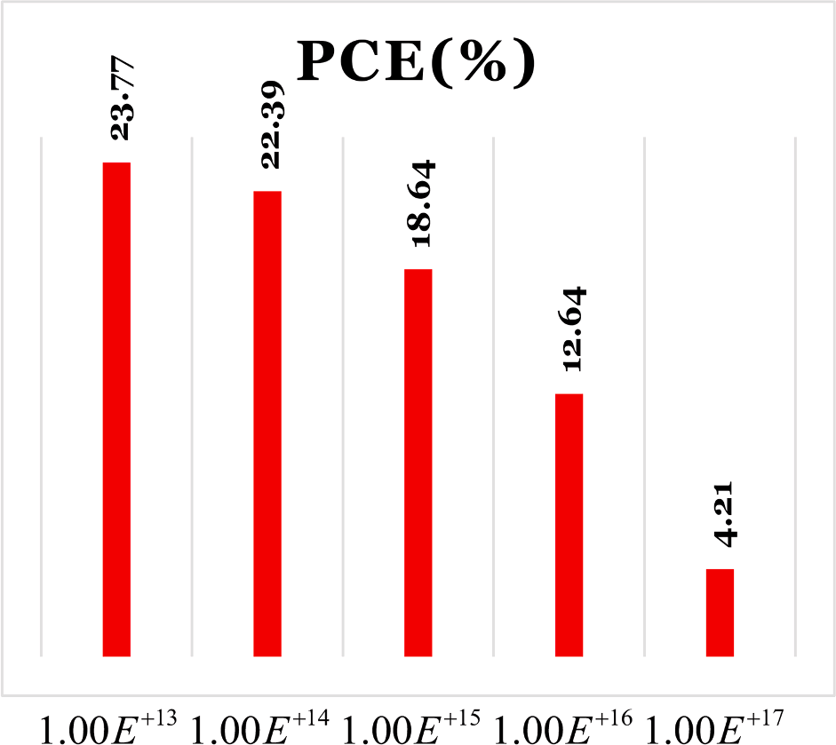
Fig. 6. Effect of absorber defect density on PCE.

Table 5
Effect of absorber defect density on J-V characteristics.
defect density(cm-3) V_{OC} (V) J_{SC} (mA/cm2) FF (%) 1.00E+13 1.1498 24.3916 84.76
1.00E+14 1.1399 24.3824 80.56
1.00E+15 1.0766 24.2909 71.27
1.00E+16 0.9506 23.4014 56.82
1.00E+17 0.7710 16.5802 32.90
Table 6
Work functions for various back metal contacts.

Back metal | Cu | Ag | Fe | C | Au | Ni
Work function (eV) | 4.7 | 4.74 | 4.81 | 5 | 5.1 | 5.15

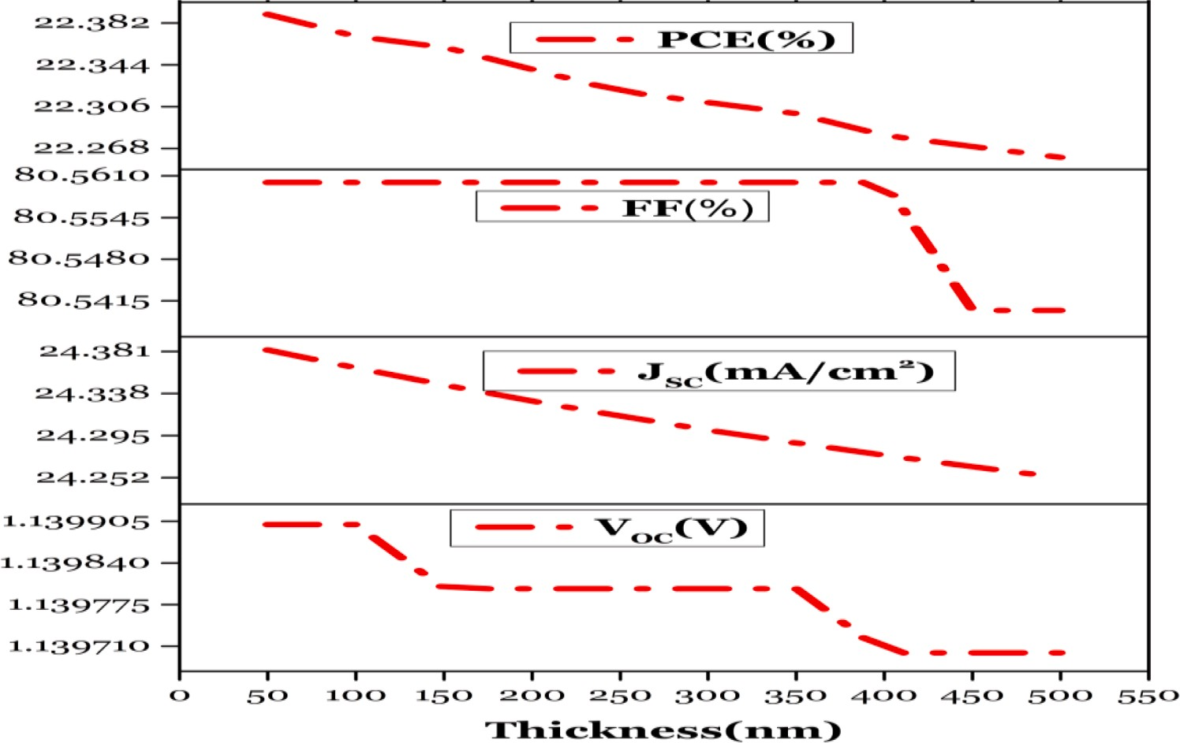
Fig. 5. Variation of PSC parameters with TCO thickness for optimization.

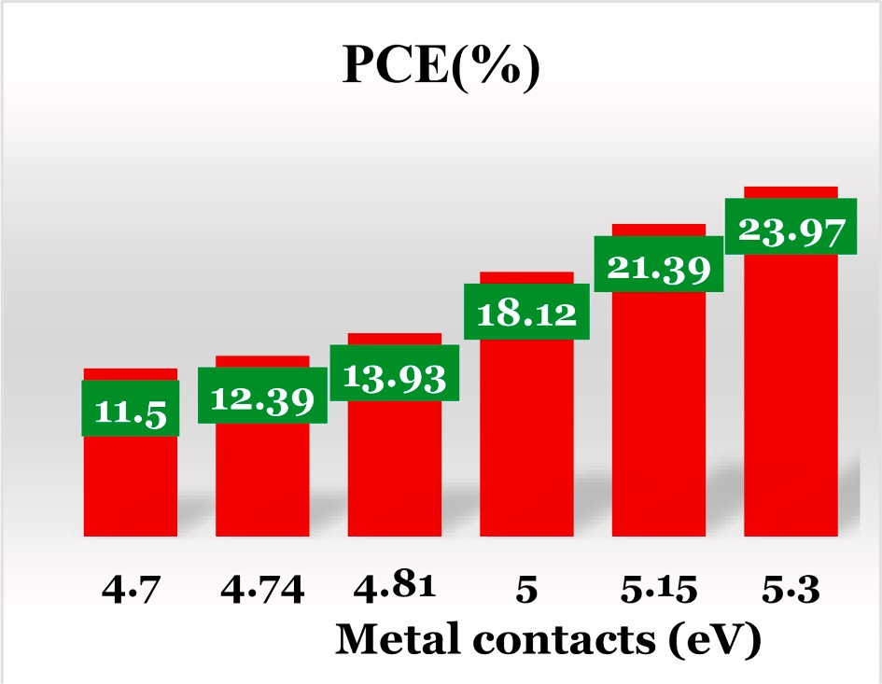
Fig. 7. Effect of metal contacts on PCE.

  - The impact of temperature on PSC performance

Different geographical regions use solar cells at different occasion of the year with varying weather conditions and climates, which affect the operation temperature of the photovoltaic. Simulations were run at various operating temperatures to see how temperature affects PSC’s
execution. At low temperatures (T < 120 K), the performance of the
device is constrained by the charge transport layer, whereas at high temperatures (T > 200 K), the interfacial charge recombination takes over. Thermal degradation of PSCs is caused by a decrease in film ab-
sorption as heating time increases due to the formation of high crys- talline orders and large domain sizes, non-equilibrium charge-carrier transport, inefficient charging, and extrinsic factors such as heat [55].
The effect of temperature change on the performance of solar cells is
depicted in Fig. 8. From the plots, it is noticeable that the PCE, FF and Voc decrease with temperature. Hence the PSC offers better perfor- mance at 300 K.

  - Effect of series resistance on PSC performance
The impact of series resistance on the PSC’s performance charac- teristics are depicted in Fig. 9(a) and (b).The Jsc rises as the series resistance rises before abruptly beginning to fall in line with the series resistance. With an increase in series resistance, PCE likewise declines. This analysis reveals how the low series resistance improves PSC per- formance. But the higher values of series resistance declines the per- formance enhancement rapidly.

  - Effect of shunt resistance on PSC performance
Fig. 10(a) and (b) depict the effects of series resistance on the PSC’s performance characteristics. The impact of shunt resistance has no in- fluence on the Jsc. The shunt resistance is more powerful at the PCE point. PCE rises in direct proportion to the rise in shunt resistance. Ac- cording to the analysis above, the shunt resistance has a significant in- fluence and exhibits good variance in PSC performance.

  - Optimized device

The schematic and electronic energy level diagram for the enhanced CuSbS₂/Cs₂TiBr₆/CdS solar cell is shown in Fig. 11(b). In relation to the Cs₂TiBr₆ absorber layer, the figure shows how the HOMO and LUMO levels of the hole transport layer promote the efficient injection of a hole and blocking of an electron. The electron transport layer’s HOMO and LUMO levels similarly aid in the effective injection of electrons and the blockage of the hole with regard to the Cs₂TiBr₆ absorber layer. As a result, the essential electronic structural framework for extremely effi- cient ETL/Cs₂TiBr₆/HTL-based PSCs is provided by the energy level

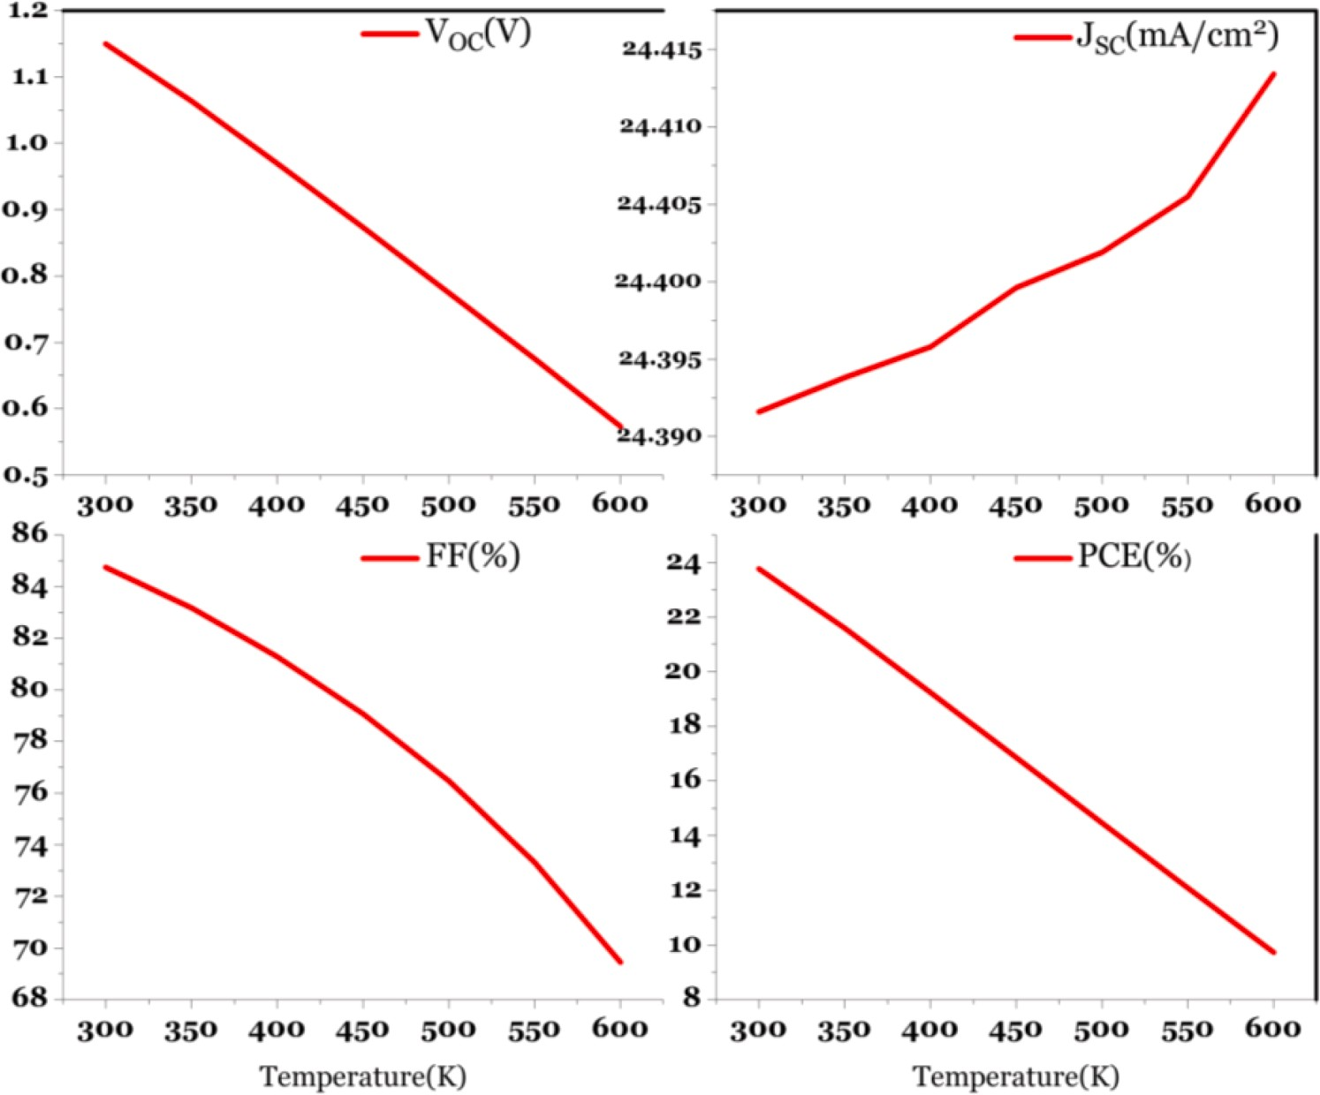
Fig. 8. Temperature effect on optimized device.

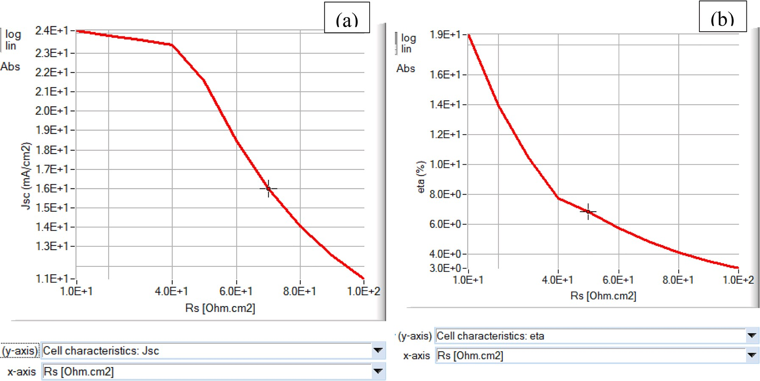
Fig. 9. Impact of series resistance on (a) J_{SC} and (b) PCE of PSC.

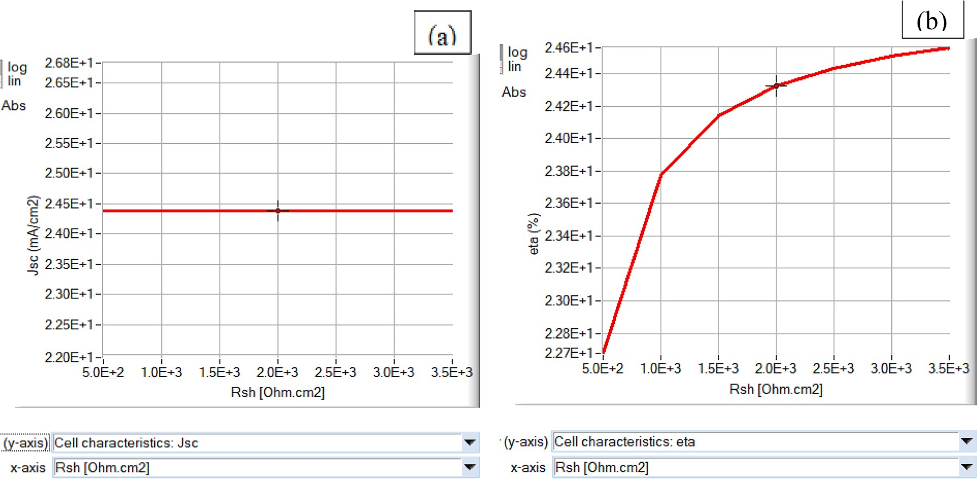
Fig. 10. Impact of Shunt resistance on (a) J_{SC} and (b) PCE of PSC.

alignment of the hole and electron transport layer with the Cs₂TiBr₆ perovskite absorber.
A solar cell’s quantum efficiency (QE) is a measurement of the ratio
of carriers to photons which can absorb. Sandwiched absorbing layers that can absorb photons with a wavelength between 790 and 820 nm may be more effective. Fig. 12 depicts the existence of all photons with wavelengths between 350 and 600 nm. After then, 90% of photons be- tween 600 and 780 nm in wavelength are still alive, and less than 10% have been mixed in different ways. As a result, practically all input photons are absorbed by the sandwiched layer between 350 and 800 nm, creating electron-hole pairs and carriers.

  - Comparative analysis structure

Table 7 evaluates the current Cs₂TiBr₆-based PSC with the suggested structure. This topic is relatively new in the field of PSCs, and there hasn’t been much research done on it. According to Table 7, our improved device outperforms previous works on PSCs based on
Cs₂TiBr₆. According to the outcomes of our studies, this device seems to perform reasonably well, and as it is a pure inorganic Ti-based perov- skite and uses entirely inorganic charge transport layers, the environ- ment span end is expected to be exceptionally stable.

Conclusion

This study presents a stable, lead-free perovskite solar cell based on Cs₂TiBr₆ that includes a variety of organic and inorganic charge trans- portation components, metal contacts, and a variety of electron trans- port materials. By carefully selecting the HTL, ETL, back metal connections, as well as the absorb layer’s characteristics, including thickness and defect density, the device seems to be stable at 300 K and operates at its peak performance. Even though the device uses several back contact metals, its efficiency is at its maximum when utilizing Au, which has a work function of 5.1 eV. The analysis of the effects of several HTL and ETL materials on the execution of the invention and the opti- mization of layer composition had an impact on the development of a

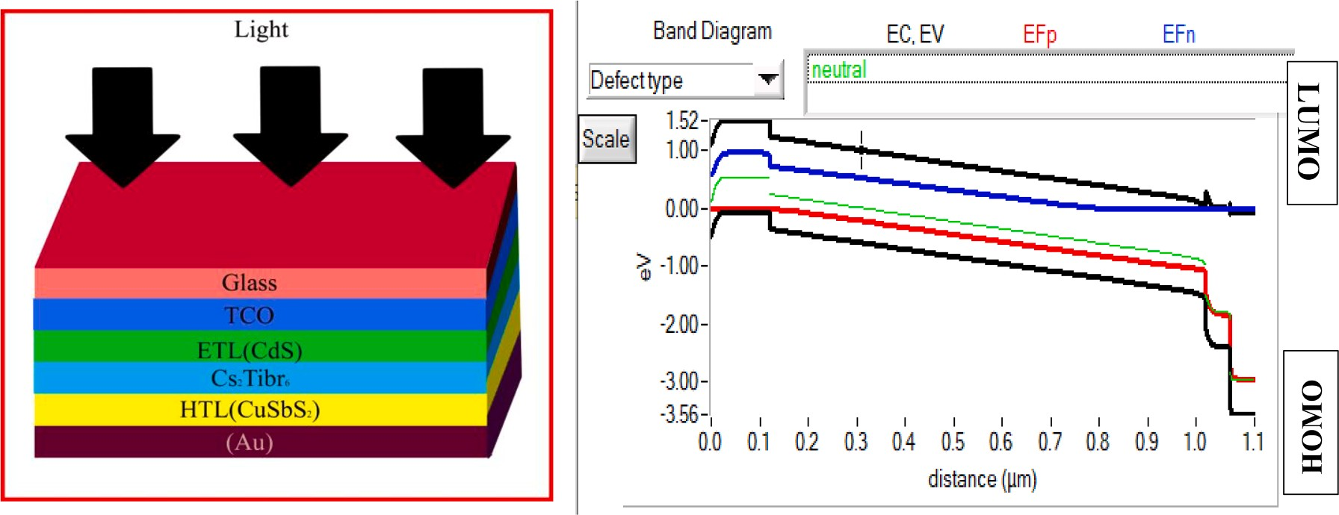
Fig. 11. (a) Schematic diagram, and (b) energy band diagram of the FTO/CdS/Cs₂TiBr₆/Cu₂SbS₂/Au.

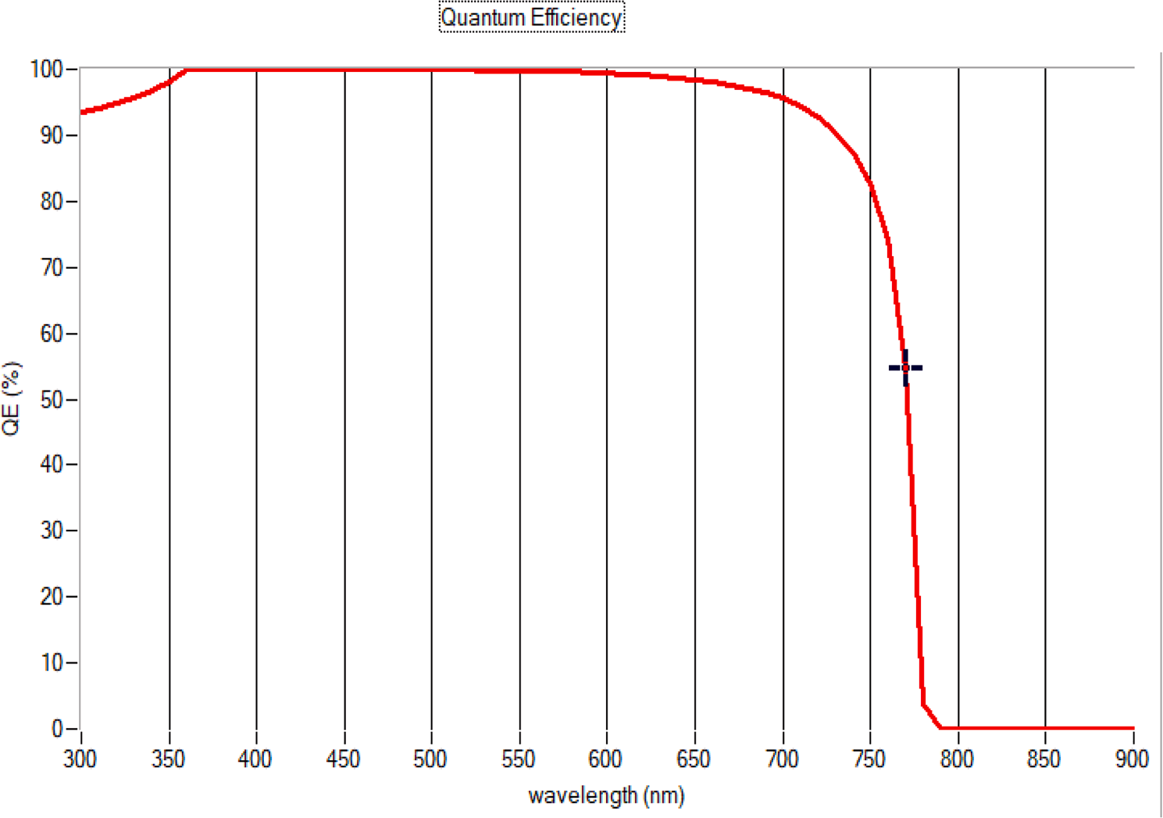

Table 7
Fig. 12. Quantum Efficiency of optimized device.

Declaration of Competing Interest

Performance comparison of existing Cs₂TiBr₆ based PSC.

Structure | PCE (%) | Ref.
FTO/TiO₂/₆/P₃HT/Au | 3.3 | [56]
FTO/TiO₂/ Cs₂TiBr₆/Cu₂O/Au | 14.68 | [57]
FTO/SnO₂/ Cs₂TiBr₆/MoO₃/Au | 11.49 | [58]
Au/PEDOT:PSS/Cs₂TiBr₆/TiO₂ | 17.83 | [59]
CeOx/Cs₂TiBr₆/NPB | 17.94 | [60]
FTO/TiO₂/Cs2TiBr₆/NiCo₂O₄/Au | 19.3 | [61]
Proposed | 23.77
FTO/CdS/Cs₂TiBr₆/Cu₂SbS₂/Au

novel, high-performance combination of TCO/CdS/Cs₂TiBr₆/Cu₂SbS₂/ Au. The highest PCE of this suggested system is 23.77%, the J_{SC} is 24.3916 mA/cm2, the V_{OC} is 1.1498 V, the FF is 84.76%, and the QE is
99% at the visible spectrum. The research framework may enable in designing lead-free, environmental friendly Ti-based PCS for techno- logical breakthroughs.
No conflict of interest.

Data availability

The data that has been used is confidential.

References
- E. Kabir, P. Kumar, S. Kumar, A.A. Adelodun, K.-.H. Kim, ‘Solar energy: potential and future prospects, Renew. Sustain. Energy Rev. 82 (2018) 894–900.
- Jianbo Wang, Zhenming Xu, Environmental friendly technology for aluminum electrolytic capacitors recycling from waste printed circuit boards, J. Hazard.
Mater. 326 (2017) 1–9.
- Elham Norouzi Afshar Mehrabian, Sonya Asl Yousefzadeh, Simulating the thickness effect of the graphene oxide layer in CsPbBr₃- based solar cells Masood Mater, Res. Express, 8 (2021).
- B. Yang, et al., Inorganic top electron transport layer for high performance inverted perovskite solar cells, EcoMat 3 (5) (2021).

- P. Gao, et al., Thioredoxin-interacting protein mediates NALP₃ inflammasome activation in podocytes during diabetic nephropathy Biochim, Et Biophys. Acta (2014).
- Q. Chen, et al., Under the spotlight: the organic–inorganic hybrid halide perovskite
for optoelectronic applications, Nano Today (2015).
- M.A. Green, The path to 25% Silicon Solar Cell efficiency: history of silicon cell evolution, Prog. Photovolt. Res. Appl. 17 (2009) 183–189.
- S. Pizzini, Towards solar grade silicon: challenges and benefits for low cost photovoltaics, Sol. Energy Mater. Sol. Cells 94 (2010) 1528–1533.
- A. Zekry et al., Solar Cells and Arrays: principles, Analysis, and Design, Chapter 1, 2018.
- J. Poortmans et al.Thin Film Solar Cells: fabrication (Characterization and Applications) 2006.
- A. Kojima, et al., Organo metal halide perovskites as visible-light sensitizers for photovoltaic cells, J. Am. Chem. Soc. (2009).
- N.G. Park, Organometal perovskite light absorbers toward a 20% efficiency low- cost solid-state mesoscopic solar cell, J. Phys. Chem. Lett. 4 (2013) 2423–2429.
- W. Liao, et al., Lead-free inverted planar formamidinium tin triiodide perovskite
solar cells achieving power conversion efficiencies up to 6.22, Adv. Mater. 28 (2016) 9333–9340.
- M. Green, et al., Solar cell efficiency tables (version 52), Prog. Photovolt.: Res. Appl. (2018).
- A. Smets, K. Ja¨ger, O. Isabella, R. Swaaij, M. Zeman. Solar Energy: the Physics and Engineering of Photovoltatics, 2016.
- Md. Tohidul Islam, et al., Numerical simulation studies of Cs₃Bi₂I₉ perovskite solar device with optimal selection of electron and hole transport layers, Optik (Stuttg) 231 (2021), 166417.
- I. Alam, M.A. Ashraf, Effect of different device parameters on tin-based perovskite solar cell coupled with In₂S₃ electron transport layer and Cuscn and spiro-ometad alternative hole transport layers for high-efficiency performance, Energy Source., Part A Recover. Util. Environ. Effects (2020).
- I. Alam, R. Mollick, M.A. Ashraf, Numerical simulation of Cs₂AgBiBr₆-based perovskite solar cell with ZnO nanorod and P3HT as the charge transport layers, Phys. B Condens. Matter 618 (2021), 413187.
- M. Burgelman, “Models for the Optical Absorption of Materials in
SCAPS,”pp.1–13,2018.
- A. Babayigit, A. Ethirajan, M. Muller, B. Conings, Toxicity of Organometal Halide Perovskite Solar cells, Nat. Mater. 15 (2016) 247–251.
- Yigang Luan, Dual-function interface engineering for efficient perovskite solar cells, EcoMat 3 (2) (2021).
- Gopi Chandra AdhikariORCID,Saroj Thapa,Yang Yue,Hongyang Zhu and Peifen Zhu, Near unity PLQY and high stability of barium thiocyanate based all-inorganic perovskites and their applications in white light-emitting diodes, Photonics, 8(6), 209;2021.
- YuruTang BaiqianWang, WensiCai XinYang, WenMa RuLi,
ChenChen ShuangyiZhao, Zan Zhigang, Stable yellow light emission from lead-free copper halides single crystals for visible light communication, Nano Materials Science (2022).
- F. Giustino, H.J. Snaith, Toward Lead-Free Perovskite Solar Cells, ACS Energy Lett 1 (2016) 1233–1240.
- M. Chen, M.-.G. Ju, A. Carl, Y. Zong, R.L. Grimm, J. Gu, X.C. Zeng, Y. Zhou, N.
P. Padture, Cesium titanium(IV) bromide thin films based stable lead-free perovskite solar cells, . Joule 2 (2018) 558–570.
- T.Li Wang, Y. Yan, D.B. Mitzi, Is Cs₂TiBr₆ a promising Pb-free perovskite for solar energy applications? J. Mater. Chem. A (2020).
- A. Slami, M. Bouchaour, L. Merad, Numerical study of based perovskite solar cells by SCAPS-1D, Int. J. Energy Environ. 13 (2019) 17–21.
- M.-.G. Ju, M. Chen, Y. Zhou, H.F. Garces, J. Dai, L. Ma, N.P. Padture, X.C. Zeng, Earth-abundant nontoxic titanium(IV)-based vacancy-ordered double perovskite
halides with tunable 1.0 to 1.8 eV bandgaps for photovoltaic applications, ACS Energy Lett. 3 (2018) 297–304.
- V. Pecunia, L.G. Occhipinti, A. Chakraborty, Y. Pan, Y. Peng, Lead-free halide perovskite photovoltaics: challenges, open questions, and opportunities, APL Mater. 8 (2020).
- G. Grandhi, A. Matuhina, M. Liu, S. Annurakshita, H. Ali-Lo¨ytty, G. Bautista,
P. Vivo, Lead-free cesium titanium bromide double perovskite nanocrystals, Nanomaterials 11 (2021) 1458.
- K. Chen, Q. Hu, T. Liu, L. Zhao, D. Luo, J. Wu, Y. Zhang, W. Zhang, F. Liu, T.
P. Russell, R. Zhu, Q. Gong, ‘Charge-carrier balance for highly efficient inverted planar heterojunction perovskite solar cells, Adv.Mater 28 (2016) 10718–10724.
- A.A. Said, J. Xie, and Q. Zhang, ‘‘Recent progress in organic electron transport materials in inverted perovskite solar cells,’’ Small, 15, 2019.
- S. Pitchaiya, M. Natarajan, A. Santhanam, V. Asokan, A. Yuvapragasam, V.
M. Ramakrishnan, S.E. Palanisamy, S. Sundaram, D. Velauthapillai, ‘A review on the classification of organic/inorganic/carbonaceous hole transporting materials for perovskite solar cell application, Arabian J. Chem. 13 (2020) 2526–2557.

- P.-.Y. Gu, N. Wang, A. Wu, Z. Wang, M. Tian, Z. Fu, X.W. Sun, Q. Zhang, ‘An
azaacene derivative as promising electron-transport layer for inverted perovskite solar cells, Chem.-Asian J 11 (15) (2016) 2135–2138.
- Song Li, Yong-Li Cao, Wen-Hua Li, Zhi-Shan Bo, A brief review of hole transporting materials commonly used in perovskite solar cell, Rare Met 40 (10) (2021) 2712.
–272.
- Faiza Azri, Afak Meftah, Nouredine Sengouga, Amjad Meftah, Electron and hole transport layers optimization by numerical simulation of a perovskite solar cell,
Solar Energy 181 (2019) 372–378.
- S. Bishnoi, S.K. Pandey, Device performance analysis for lead-free perovskite solar cell optimization, IET Optoelectron 12 (2018) 185–190.
- Nitin Rai, Shambhavi Rai, Pravin Kumar Singh, Pooja Lohia, D.K. Dwivedi;, Analysis of various ETL materials for an efficient perovskite solar cell by numerical simulation, Journal of Materials Science: Materials in Electronics 31 (2020)
16269–16280.
- J.A. Owolabi, M.Y. Onimisi, J.A. Ukwenya, A.B. Bature, U.R. Ushielepan, Investigating the effect of ZnSe (ETM) and Cu2O (HTM) on absorber layer on the
performance of pervoskite solar cell using SCAPS-1D, pp. 8–18, 2020.
- M.M. Salah, K.M. Hassan, M. Abouelatta, A. Shaker, A comparative study of different ETMs in perovskite solar cell with inorganic copper iodide as HTM, Optik
(Stuttg) 178 (2019) 958–963.
- J. Qi, W. Liu, C. Biswas, G. Zhang, L. Sun, Z. Wang, X. Hu, Y. Zhang, Enhanced power conversion efficiency of CdS quantum dot sensitized solar cells with ZnO
nanowire arrays as the photoanodes, Opt. Commun. 349 (2015) 198–202.
- M. Burgelman, P. Nollet, S. Degrave, ‘Modelling polycrystalline semiconductor solar cells, Thin Solid Films 6 (2000) 361–362, 527–532.
- K. Wang, S. Olthof, W.S. Subhani, X. Jiang, Y. Cao, L. Duan, H. Wang, M. Du, S.
F. Liu, ‘Novel inorganic electron transport layers for planar perovskite solar cells: progress and prospective, Nano Energy 68 (2020).
- J. Verschraegen, M. Burgelman, ‘Numerical modeling of intra-band tunneling for heterojunction solar cells in SCAPS, Thin Solid Films 515 (2007) 6276–6279.
- Jani Md Rafsun, et al., Exploring solar cell performance of inorganic Cs₂TiBr₆ halide double perovskite: a numerical study, Superlatt. Microstruct. (2020).
- M.I. Hossain, F.H. Alharbi, N. Tabet, Copper oxide as inorganic hole transport material for lead halide perovskite based solar cells, Sol. Energy 120 (2015)
370–380.
- M. Shasti, A. Mortezaali, Numerical study of Cu₂O, SrCu₂O₂, and CuAlO₂ as holetransport materials for application in perovskite solar cells, Phys. Status Solidi Appl. Mater. Sci. 216 (2019) 1–10.
- R. Teimouri, R. Mohammadpour, Potential application of CuSbS₂ as the hole transport material in perovskite solar cell: a simulation study, Superlattice.
Microst. 118 (2018) 116–122.
- U. Mandadapu, S.V. Vedanayakam, K. Thyagarajan, Simulation and analysis of lead based perovskite solar cell using SCAPS-1D, Indian J. Sci. Technol. 10 (2017)
1–8.
- A.B.R. Radhakrishnanb, R.N.R. Jeyakumar, Effect of absorber layer, hole transport layer thicknesses, and its doping density on the performance of perovskite solar
cells by device simulation, Solar Energy 196 (2020) 177–182.
- M. Shahiduzzaman, K. Yamamoto, Y. Furumoto, T. Kuwabara, K. Takahashi,
T. Taima, Enhanced photovoltaic performance of perovskite solar cells via modification of surface characteristics using a fullerene interlayer, Chem. Lett. (2015).
- M. Joachim, R. Bernd, J. Springer, M. Vanecek, TCO and light trapping silicon thin film solar cells, Science Direct 77 (2004) 917–930.
- R. Gordon, Criteria for choosing transparent conductors, MRS Bull. 25 (2000) 52–57.
- M. Chadel, M.M. Bouzaki, A. Chadel, M. Aillerie, B. Benyoucef, Thickness optimization of the ZnO based TCO layer in a CZTSSe solar cell. Evolution of its performance with thickness when external temperature changes, Journal of Physics: Conference Series 879 (2017), 012006.
- Manala Tabu, MauriceMalouangou MbumbaDavy, Jadel MatondoTsiba, YifanYang LuyunBai, MinaGuli Degradation mechanism and addressing techniques of thermal instability in halide perovskite solar cells, Solar Energy 230 (2021)
954–978.
- MinChen and, et al., Cesium titanium (IV) bromide thin films based stable lead-free perovskite solar cells, Joule 2 (2018) 558–570.
- Jani Md Rafsun, et al., Exploring solar cell performance of inorganic Cs2TiBr6 halide double perovskite: a numerical study, Superlatt. Microstruct. 146 (2020).
- Numerical development of eco-friendly Cs₂TiBr₆ based perovskite solar cell with all-inorganic charge transport materials via SCAPS-1D, Optik (Stuttg) 225 (2021), 165765.
- Syed Abdul Moiz, A.N.M. Alahmadi, Abdulah Jeza Aljohani, Design of a Novel Lead-Free Perovskite Solar Cell for 17.83% Efficiency, IEEE Access 9 (2021).
- Syed Abdul Moiz, Optimization of hole and electron transport layer for highly efficient lead-free Cs2TiBr6-based perovskite solar cell, Photonics, 9, 23 2022.
- M. Mottakin, et al., Photoelectric performance of environmentally benign Cs₂TiBr₆- based perovskite solar cell using spinel NiCo2O4 as HTL, Optik (Stuttg) 272 (2023).

